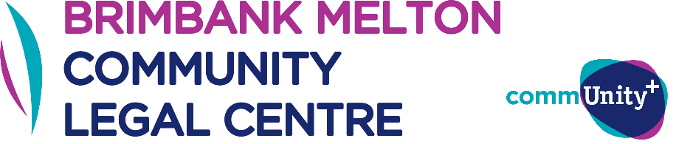

**BMCLC African Australian Assistance Project**

**Volunteer Application Form**

**Application Process**

If you are interested undertaking volunteering with African Australian Assistance Project, please email the below documents to legal@comm-unityplus.org.au:

1. A brief cover letter addressing the volunteer selection criteria (below) and letting us know why you would like to undertake volunteering with our African Australian Assistance Project;
2. A completed BMCLC African Australian Assistance Project Volunteer Application Form (next page); and
3. A copy of your current resume/CV.

Please ensure that you write “African Australian Assistance Project - Volunteer Application” in the subject line of your email.

We will review your application once you submit the above. Please note that only successful applicants will be notified, however if we don’t have current capacity for additional volunteers we will retain your application and may contact you in the future when additional capacity becomes available.

**Selection Criteria**

BMCLC receives many volunteer applications and only has limited capacity to host volunteers. We also have existing arrangements requiring us to take on placements.

Due to our limited capacity, for this project we will prioritise volunteers that:

* Have knowledge and understanding of the African Australian communities in Melbourne’s West;
* Have a connection to the Brimbank, Melton or Bacchus Marsh areas;
* Come from culturally or linguistically diverse backgrounds;
* Come from other diverse or disadvantaged backgrounds;
* Have a commitment to social justice and the values of BMCLC;
* Are able to commit to volunteering with us for at least 6 months; and/or
* Have not had an opportunity to gain legal experience elsewhere.

**Volunteering Time Commitments**

BMCLC can only host volunteers for this project who can commit to at least one day per fortnight volunteering with the Centre. Volunteering days generally take place on a Monday.

Please note that volunteering with this project may involve travelling to offsite, project- based locations. Volunteers will need to make their own arrangements for travel to these locations.

**BMCLC African Australian Assistance Project Application Form**

**Personal details**

Name:

Phone number:

Email:

**Do you have a connection to the Brimbank, Melton or Bacchus Marsh area?**

☐ No

☐ Yes (please ensure details are provided within your Cover Letter)

**Are you currently studying, or have you recently completed, a law degree?**

☐ No

☐ Yes (please ensure that your resume/CV indicates where you are up to with your studies)

**Are you looking to count your volunteering towards a PLT or university requirement?**

☐ No

☐ Yes – please provide details of the number of days/hours required:

**Can you commit to a six-month volunteering placement?**

☐ Yes

☐ No

**What days are you currently available to volunteer?**

☐ Mondays

☐ Tuesdays

☐ Wednesdays

☐ Thursdays

☐ Fridays

Any other comments about your availability: